**Corn Maize Leaf Disease Detection**

**PROJECT REPORT**



**SUBMITTED BY:**

Mabtoor-Ul-Shafiq

Contact : +923487330483

**SUBMITTED TO:**

METAFOURT Technologies

**ABSTRACT**

Corn Maize Leaf Disease Detection is an innovative technology that helps farmers to improve the quality and quantity of agricultural production in the country. Disease of corn and maize has been one of the major threats to food security since long ago because it reduces the crop yield and compromises its quality. The existing method for detecting the disease of corn and maize is simply naked eye observation by experts through which identification and detection of disease of corn and maize is done. For doing so, a large team of experts is required to detect the disease of corn and maize , which costs very high when we do with large farms. At the same time, in a few nations, farmers don't have appropriate facilities or the concept that they can contact specialists. Due to which consulting specialists Required High cost as well as time consuming as well. In such conditions, the recent advances in computer vision made possible by deep learning has paved the way for camera assisted disease diagnosis for detecting disease of corn and maize. It described the innovative solution that provides efficient disease detection and deep learning with Transfer learning has achieved great success in the classification of various corn maize disease detection. A variety of neuron-wise and layer-wise visualisation methods were applied and trained using a Transfer learning, with a publicly available plant disease given image dataset. So, it observed that deep learning models can predict the classification of diseases of corn and maize in the agriculture field. The proposed system is able to detect disease of corn and maize class with 96% accuracy.

# 

# 

# **INTRODUCTION**

## **Background:**

The society of agriculture countries, especially Pakistan, needs to increase the production of corn and maize by an estimated 70% by 2050 to feed an expected population size that is predicted to be over 9 billion people. Currently, infectious diseases reduce the potential yield by an average of 40% with many farmers in the developing world experiencing yield losses as high as 100%. The widespread distribution of smartphones among crop growers around the world with an expected 5 billion smartphones by 2020 offers the potential of turning the smartphone into a valuable tool for diverse communities growing food. One potential application is the development of mobile disease diagnostics through machine learning and crowdsourcing.By using such a type of model in application which gives you 96% accuracy, you can increase the production of corn and maize in developing countries and helps to reduce minimum loss.

## **Description:**

Our Goal is to minimise or reduce the loss of corn and maize that happens due to different diseases. Our Objective is to design and develop a machine learning model that gives us maximum accuracy and minun loss. The Traditional method is simply using naked eye to check or detect whether the corn or maize is healthy or diseased. For that purpose, you need to require a large number of teams for monitoring the corn and maize plants which require a very high cost . At the same time , some developing countries like Pakistan do not have proper facilities and resources to monitor corn and maize plants using a large number of teams. Due to which consulting experts even cost high as well as time consuming too. In such conditions, you always need to use AI Models that give you maximum accurate result and minimise the corn and maize loss. Automatic detection of the diseases by just seeing the symptoms of the leaf of corn and maize makes it easier as well as cheaper. For this purpose, we used deep learning pre-trained models to classify the disease of corn and maize plants.

## **Problem Statement:**

## The disease present in corn and maize has been one of the major threats to food security since long ago because it minimises the production of corn and maize and compromises its quality. The Traditional method is simply using naked eye to check or detect whether the corn or maize is healthy or diseased. For that purpose, you need to require a large number of teams for monitoring the corn and maize plants which require a very high cost . At the same time , some developing countries like Pakistan do not have proper facilities and resources to monitor corn and maize plants using a large number of teams. Due to which consulting experts even cost high as well as time consuming too.. For thispurpose, we will use a deep learning model to classify different plants and diseases of the plants.

## **Scope:**

First of all , different types of corn and maize leaf data must be collected. Preprocessing of balanced data which gives you annotation and labelling of the data must be done. A model should be trained/developed on the training data and must be evaluated on test data. Graphs must be plotted to check the accuracy and loss of data and models must be saved in standard format for further use.

### **Objectives:**

* Goal: To develop Corn and Maize leaf disease detection model
* Objective 1: Data must be collected first.
* Objective 2: Data should be labelled and annotated before we pass it to model.
* Objective 3: Deep Learning model must be created.
* Objective 4: Model be trained to get maximum accuracy
* Objective 5: Evaluate the model and Visualise to see results.
* Objective 6: Make Confusion Matrix and Classification Report

# **Dataset Description**

For this purpose, we used a dataset from kaggle. The Corn [and Maize leaf dataset](https://www.kaggle.com/datasets/smaranjitghose/corn-or-maize-leaf-disease-dataset) is Available in [Kaggle](https://www.kaggle.com/). After picking the dataset, the other responsibility is to balance the dataset as we can see the dataset is unbalanced so we have to balance the dataset so that this will be used to develop Deep learning models and the dataset is uploaded in google drive.

Now connect this drive in Colab notebook and load the dataset using python code as shown in figure.The dataset is in the zip file so it is necessary to unzip the file . For this purpose, the ZipFile function is used to unzip the dataset in google colab.

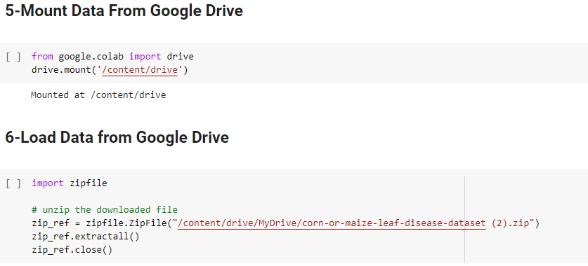

After that , we have to check the classes of our dataset, for this purpose, we used some python scripts to display the classes of corn and maize dataset

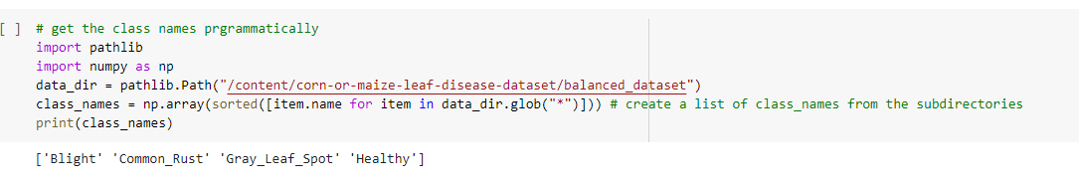

# **Problem to be addressed**

Our Task is to classify the corn and maize disease.Now we load our dataset and display its classes but the dataset is still not useful for us. We have to split the dataset into train , test and validation directories. The training data is used to train the model so that model is trained and learns the features of images using train data. The validation data is used to validate the training data after each epoch to check the correctness and remove errors. The test data is used to evaluate the model so that our model is able to learn the feature of our dataset.

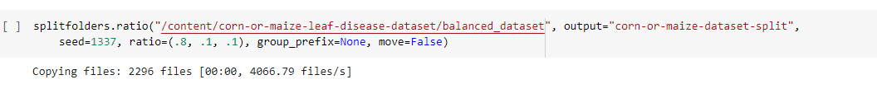

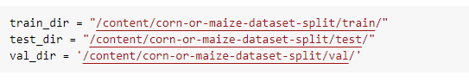

# **Artificial Intelligence Model**

### **Summary**

We used Two different Artificial Intelligence Models of Transfer Learning. The First one is the EfficientNetV2B3 model and the second one is the EfficientNetB4 Model. We used two different models to get the maximum accuracy and minimum loss. In the EfficientNetV2B3 Model, we got 96% accuracy and In EfficientB4 Model, We got 93% accuracy.

### **Data Preprocessing & Visualisation**

After Splitting data into train, test and validation directories, we have to preprocess the data and becoming one with data

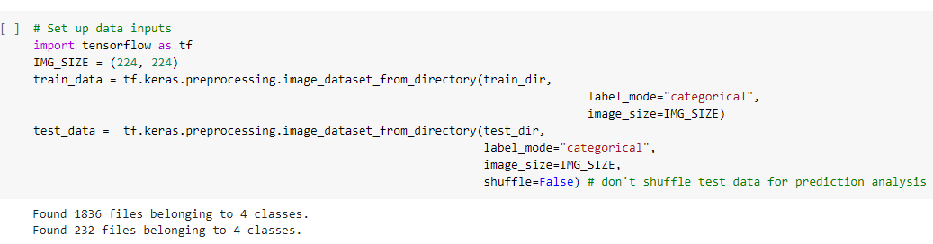

After that, We create a callback function to save checkpoints.

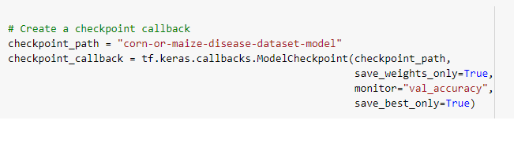

### **Model Training and Evaluation**

After preprocessing data, Now it's time to train the model. Firstly, We load pretrained models and include layers that must be frozen. After that we create a base model and add Augmented data.

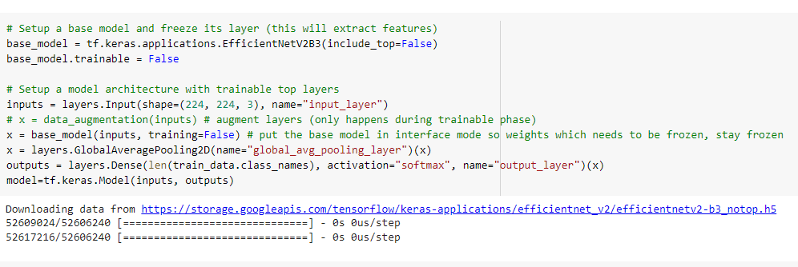

After that, we compiled the data and We used 15% of data in validation data.

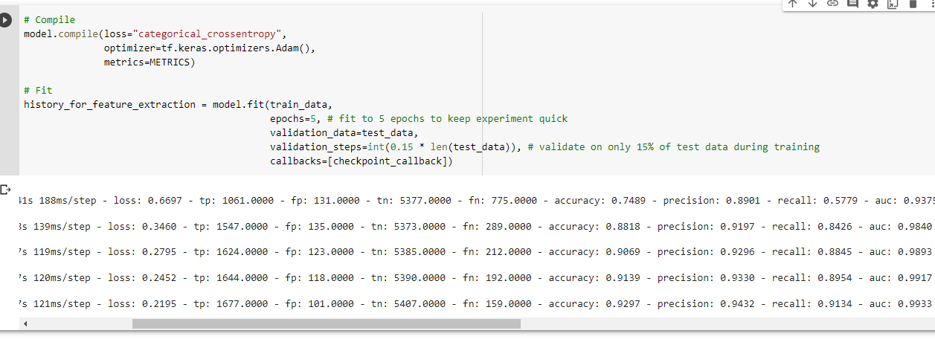

After that, We unfreeze the layers and fine tune the model, to get maximum accuracy and minimum loss.

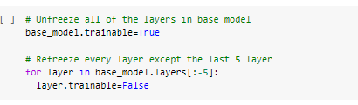

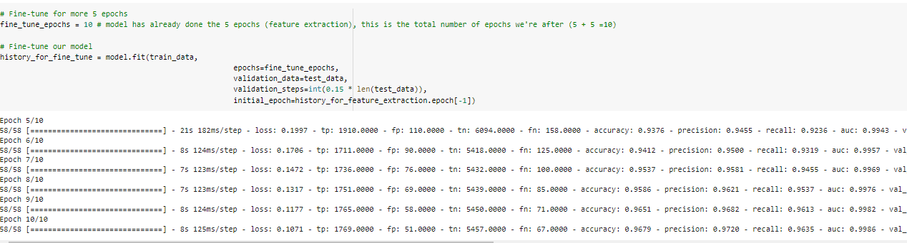

After Feature Extraction and Fine Tuning, We compare Both Plots and compare results.

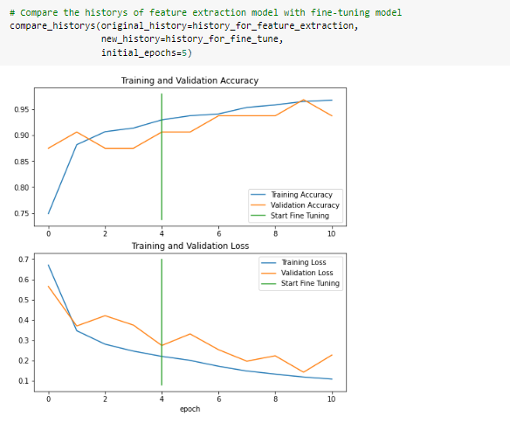

After that, we create confusion matrix to check whether our model is confused or not

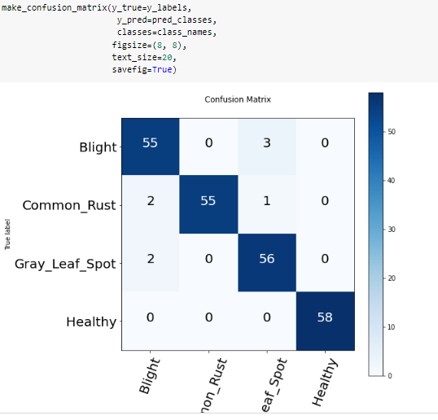

After Confusion Matrix, We Have to check our model in Random images so we took images from google and loaded them in a colab to predict whether our model works good or not. Here are the results

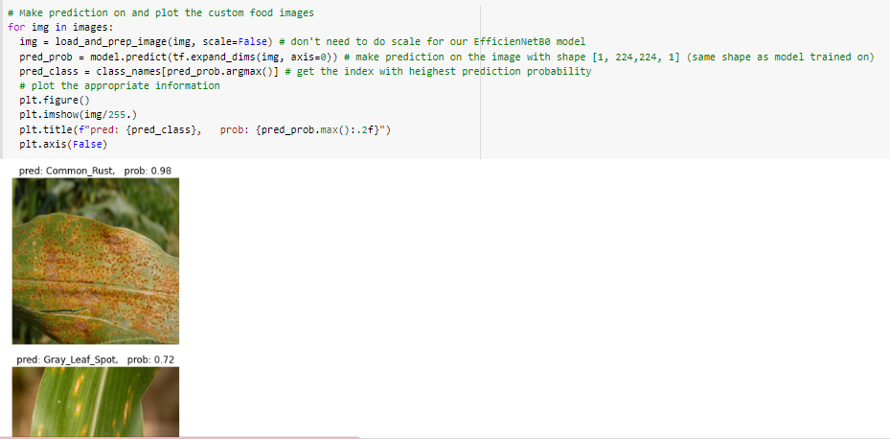

## **Conclusion**

In the end, this type of model is very helpful to detect the disease of corn and maize leaf.this model will be very helpful to increase the production of corn and maize in developing countries where 60-70% of revenue is generated from agriculture fields. By using this model, you have to increase the accuracy of corn maize leaf and minimise its loss.

## **References**:

<https://www.kaggle.com/datasets/smaranjitghose/corn-or-maize-leaf-disease-dataset>

<https://keras.io/api/applications/>